Assignment 2 – Estimating Teacher Knowledge

Q1:

A probability distribution of Riccardo’s knowledge of Cogsci, estimated with grid approximation.   
The grid has 100 divisions.  
Read from the graph, the highest probability is that his knowledge is at 0.5.   
A quadratic approximation supports this. (Mean 0.5, SD 0.2).

Since the distribution is symmetric around 0.5, there is 50% chance of Riccardo knowing more than that. When taking the sum of all datapoints above 0.5 knowledge, the same result is achieved.

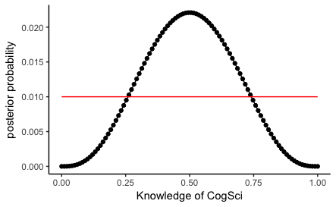

Q2:

Probability distribution for Kristian:

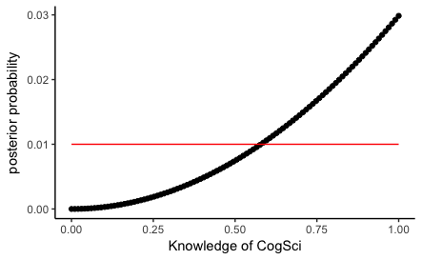

For Josh:

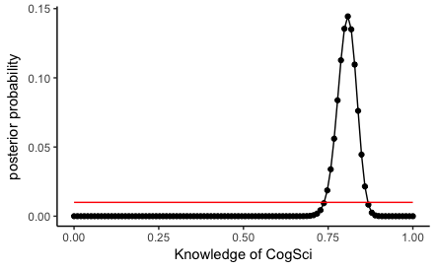

And for Mikkel:

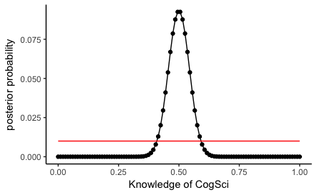

Both Riccardo and Mikkel are centered around 0.5 knowledge. But Mikkels distribution is more narrow. For Riccardo, it is less certain that he is at 0.5 – he could also be above or below. In this case, this is because we have more datapoints for Mikkels distribution.

It is difficult to say which teacher is best. Josh’s distribution is centered at around 0.8, and it is fairly narrow. As such, we are very certain that he has a knowledge – estimated to 100% to be above 0.5. Kristian’s is less certain. He might only be at chance level – there is a 88% chance for him to have above-chance knowledge. On the other hand, he could also have perfect knowledge. Which of these are best is a matter of what the situation calls for. Note that Josh’s inability to be bored might prove a great asset. It also indicates that he indeed knows more - someone who gets easily bored I would expect to know less. Also I do not expect anyone – even Kristian – to have perfect knowledge of anything. These things should inform my priors. I expect Josh to be best.

Q3:

Probability distributions of priors and posteriors for each teacher:

Riccardo:

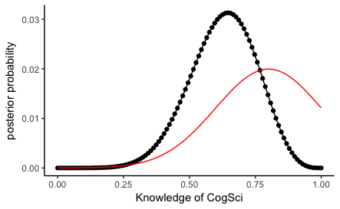

Kristian:

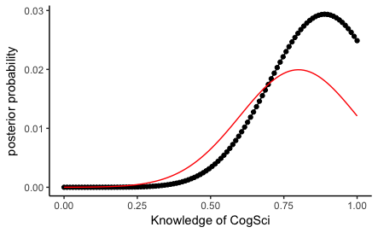

Josh:

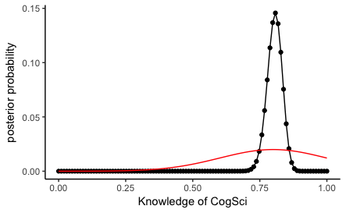

Mikkel:

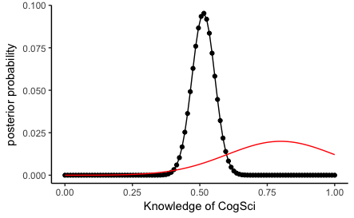

Only the uncertain plots change: Riccardo’s and Kristians. The prior fits well with Josh’s new data, and Mikkel’s data is very certain from before, so it is only slightly skewed to the right by the different prior. Riccardo’s is more skewed to the right. And Kristian becomes closer to normal distributed, and the chance of him having perfect knowledge is reduced.

Q4:

New plots for each teacher with hundred times the amount of data:

First with uniform priors:

Riccardo:

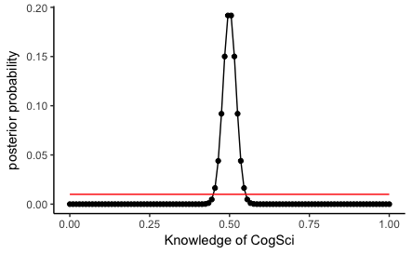

Kristian:

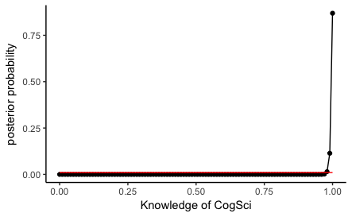

Josh:

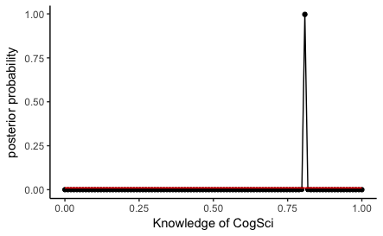

Mikkel:

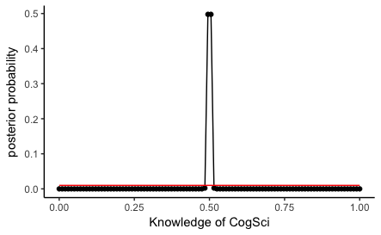

And with normal priors:

Riccardo:

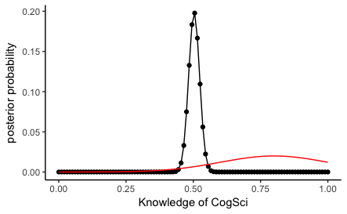

Kristian:

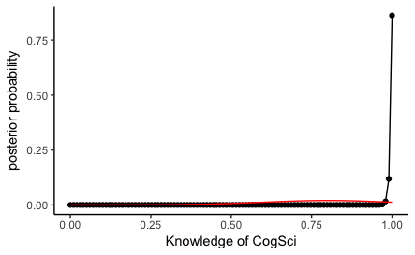

Josh:

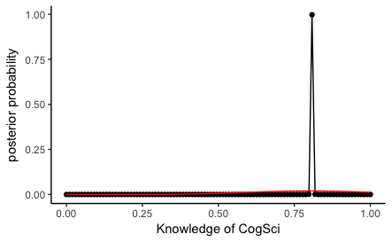

Mikkel:

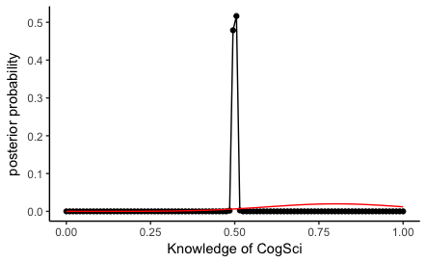

The priors now no longer have a relevant effect on the posterior distribution. There is so much data that it by far outweighs the much less certain priors.  
The distributions are now for all teachers much more certain. For example, Kristian’s is centered strongly around perfect knowledge – because he has only gotten correct answers.

With so many data points, the slopes becomes much steeper. Thus, the grid with only a 100 divisions is not adequate. This is seen in peaks consisting only of one data point.